 **Introduction To Computer Science**

**BCS/BS 1A**

ITC semester project report

TOPIC: SKYVIEW RESORT

# GROUP MEMBERS:

AHSAN RAZA (GR)

MUHAMMAD SHAYAN

NAQI ASKARI

SKYVIEW RESORT

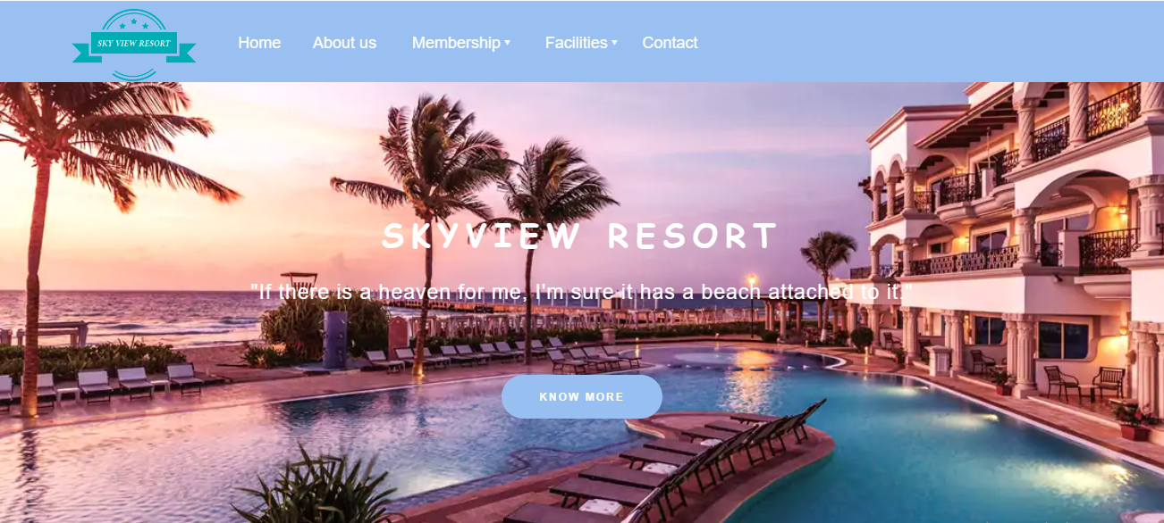

WEBSITE INTRODUCTION

• Our ITCL semester project is static website.

• Topic: SKYVIEW RESORT

• We made our website on visual studio code.

• In our website we’ve used HTML/CSS Languages.

• This website is an exclusive, world-class resort built to international standards for the fun-loving people of Karachi.

• Skyview Resort is the center of cultural & social events of Karachi. Skyview Resort is a membership-based resort located in the center of the town.

• We have developed a hotel resort website (SKYVIEW RESORT).

This website can be used to view the resort virtually, to take details about the resort and booking it.

• Whether you’re a thrill-seeker, a leisure-lover, or a mischievous toddler, we have an attraction just for you. With breathtaking water slides, adventurous river rapids, a colossal wave pool, and a giant kid’s water castle, Skyview Resort is the only choice in Karachi for those seeking a variety of quality water activities for the entire family.

**HOME PAGE**

* The home page, User can interact by watching the view of breathtaking water slides, adventurous river rapids, a colossal wave pool, and a giant kid’s water castle.
* There is tiny information regarding the facilities that resort have like (Fitness Gym, Pools).
* There is the virtually view of the resort.

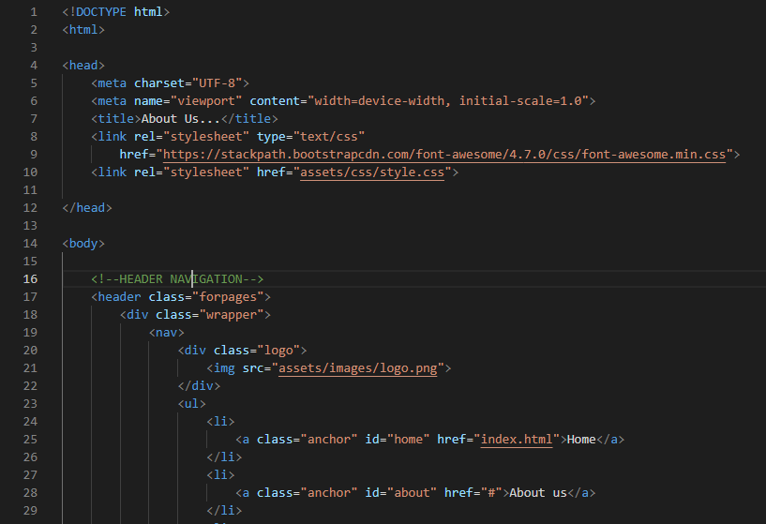

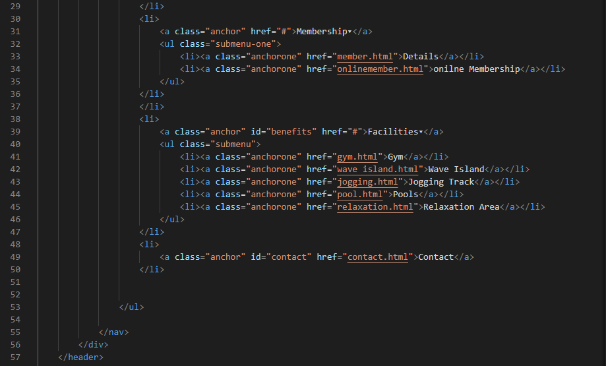

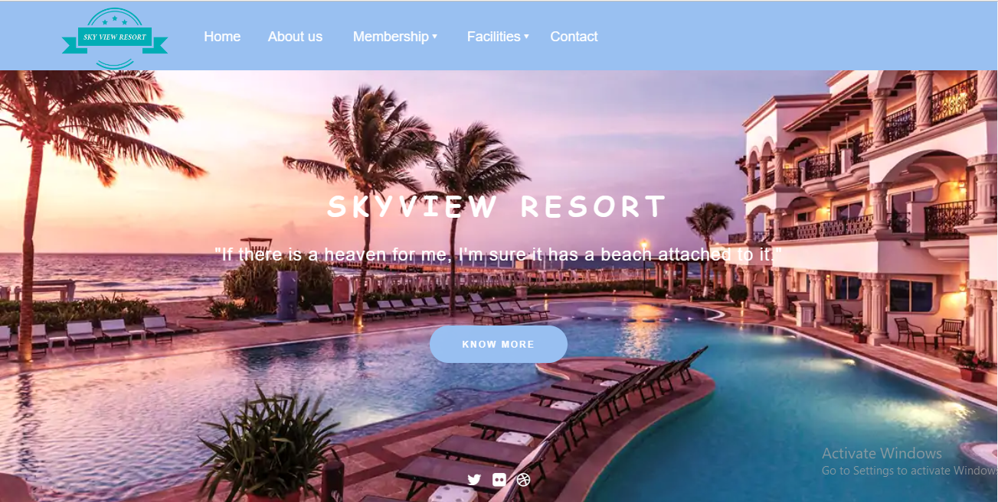

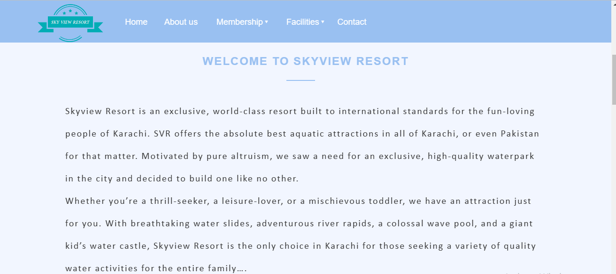

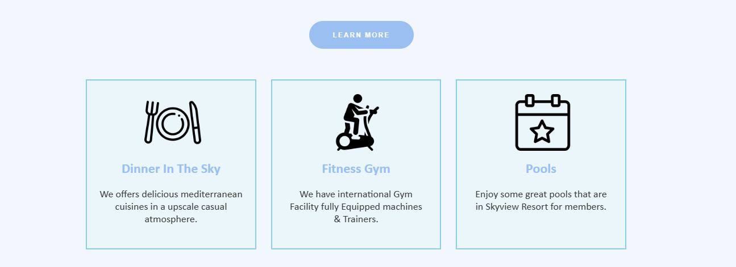

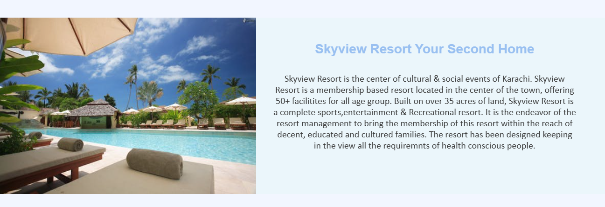

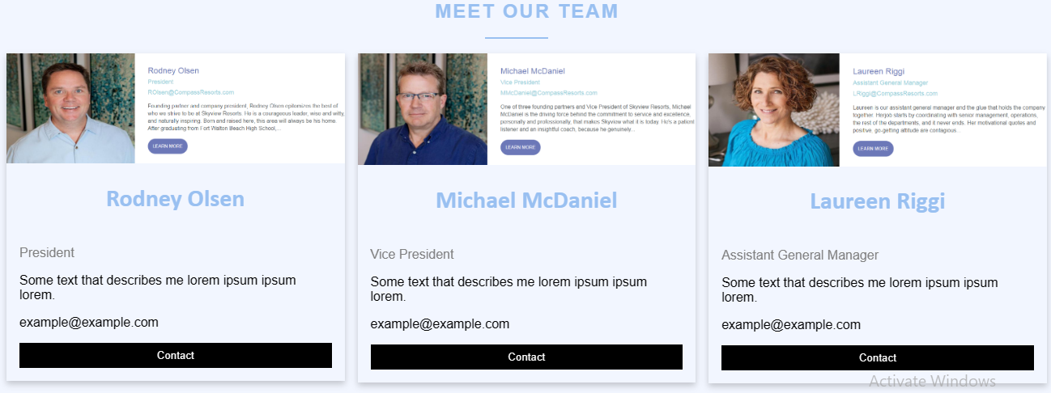

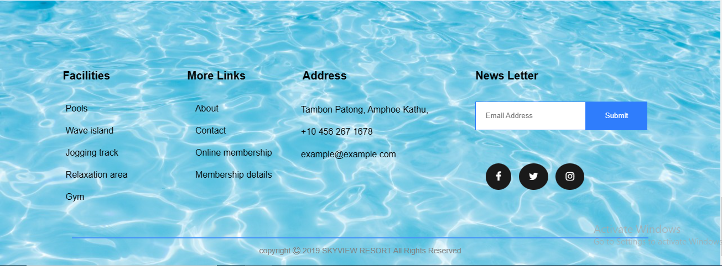

**ABOUT US SECTION**

* The about us page, inform more about the location restaurant of the resort.
* This tells the reader what the restaurant provides.

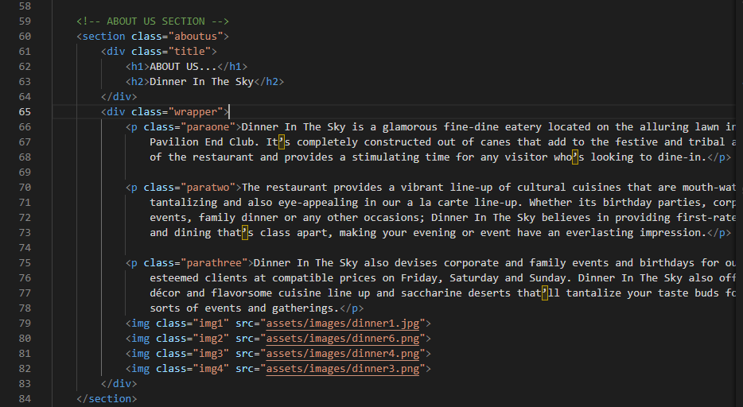

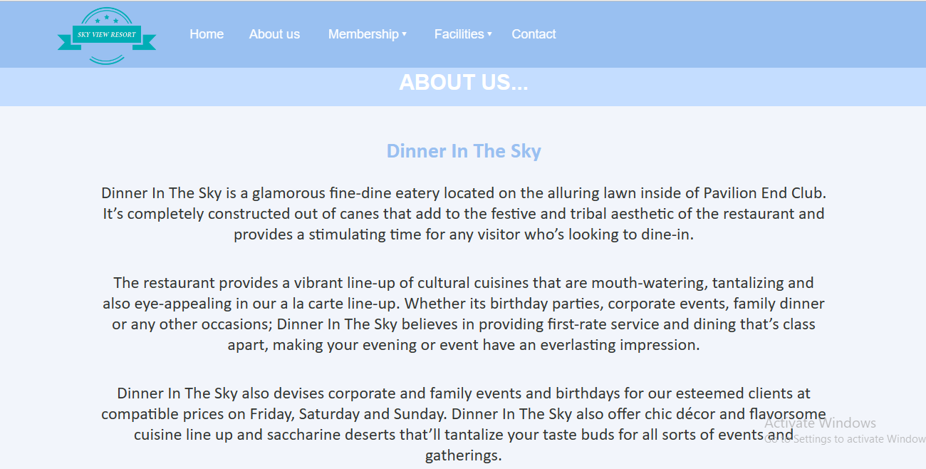

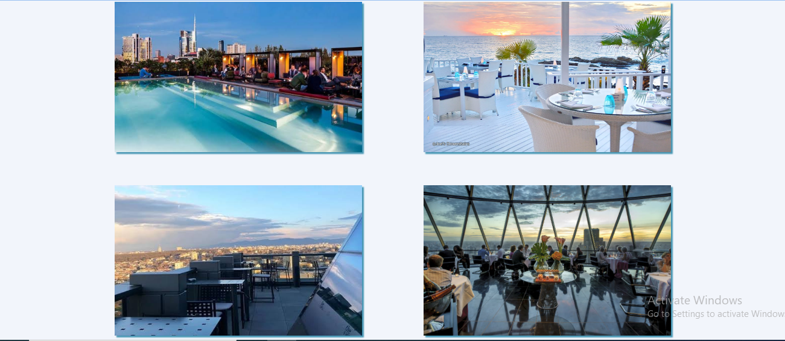

**FACALITIES**

* This webpage is used to tell the visitors about the facilities we provide in the resort.

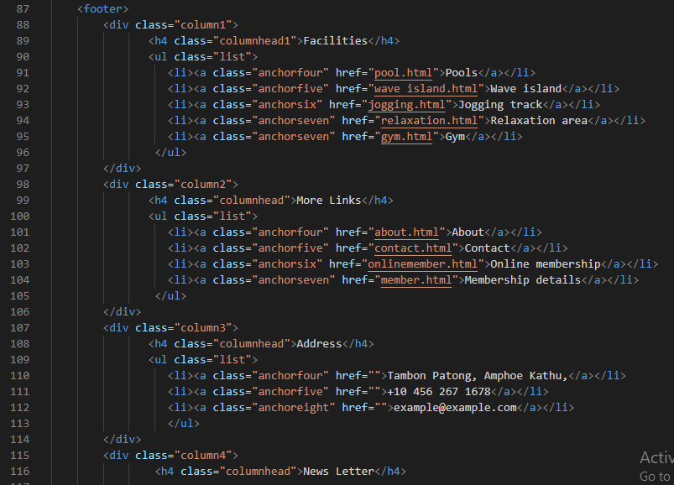

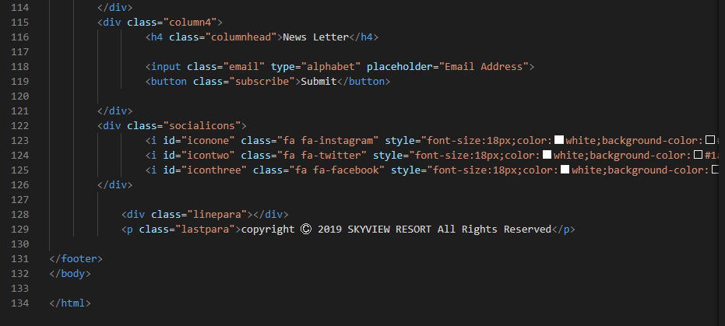

**pool section**

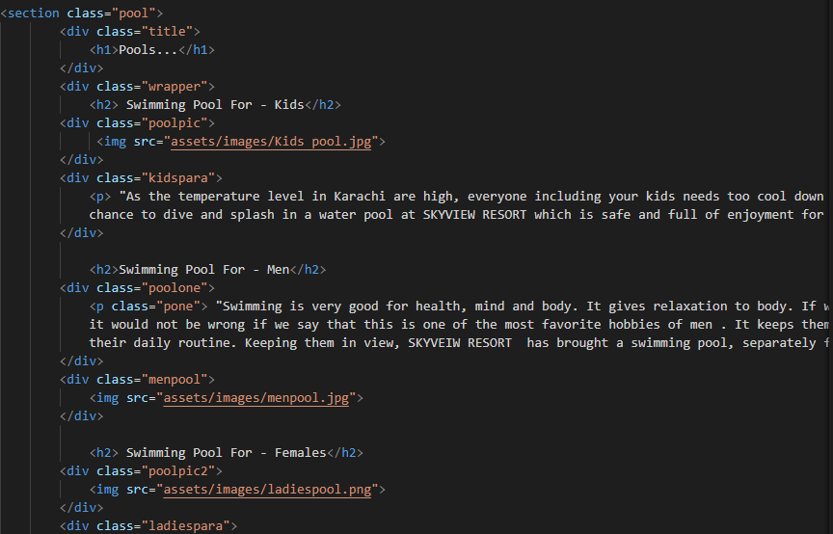

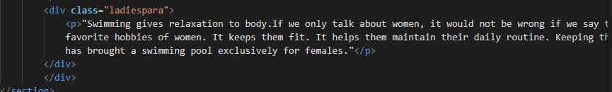

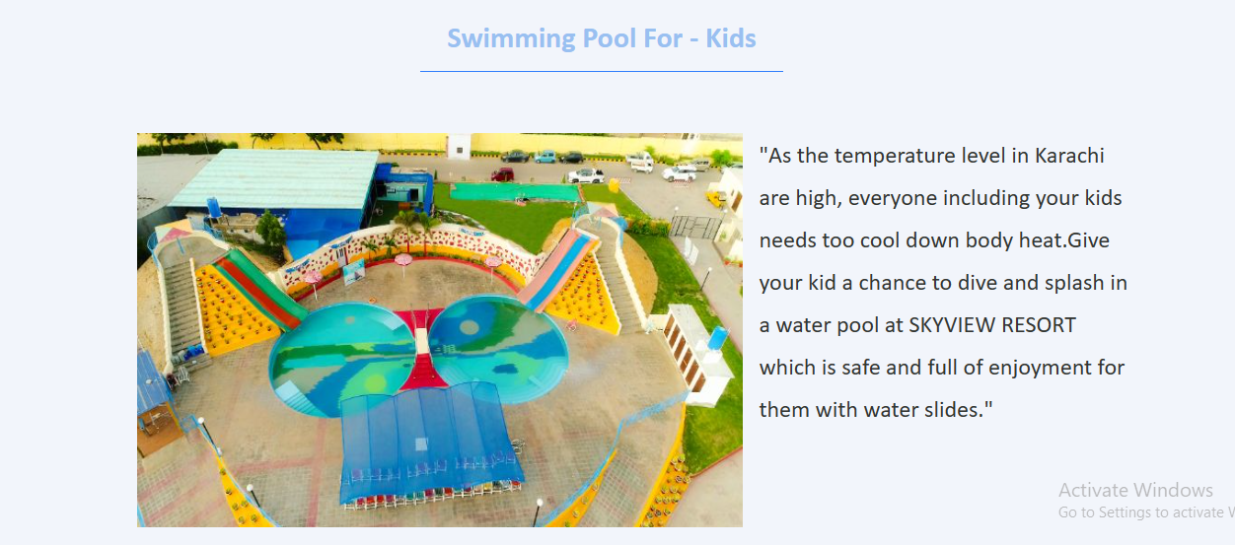

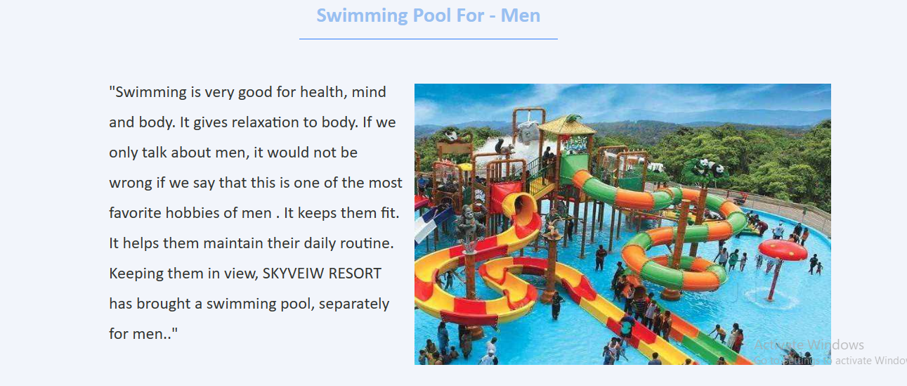

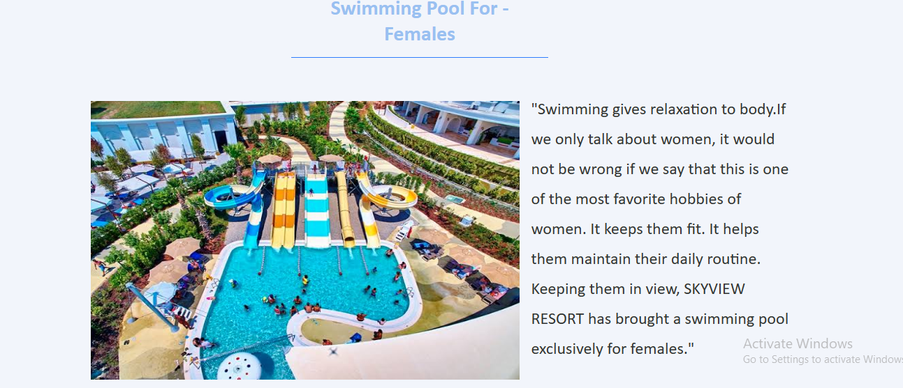

**Wave island**

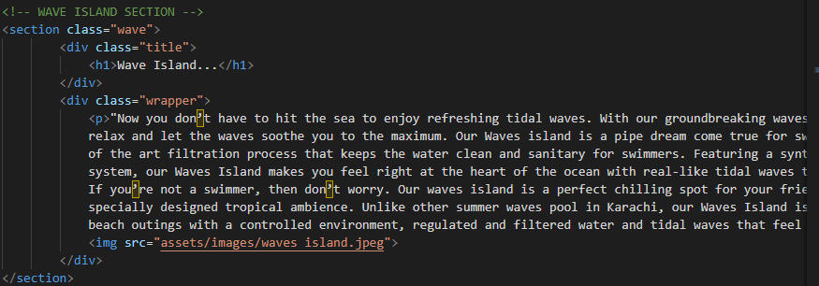

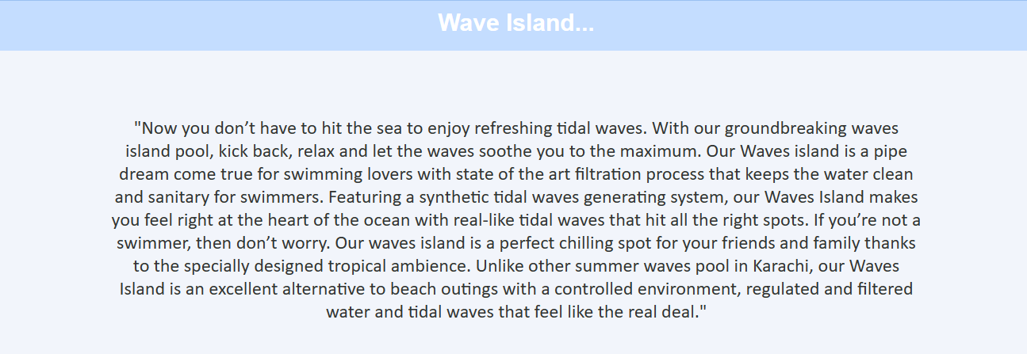

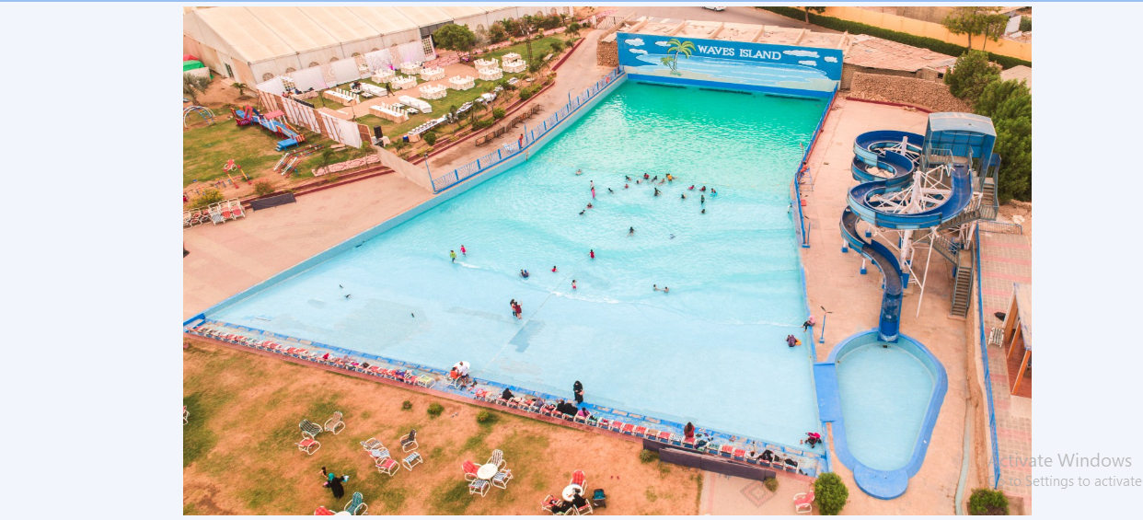

**Jogging section**

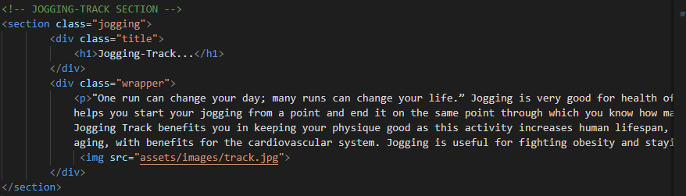

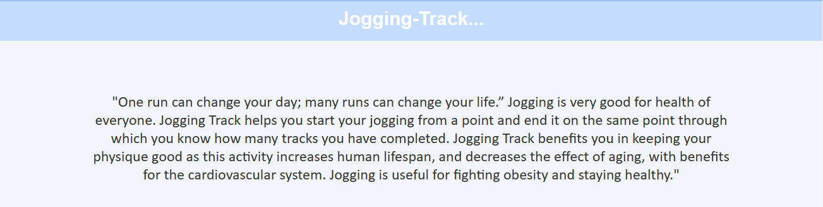

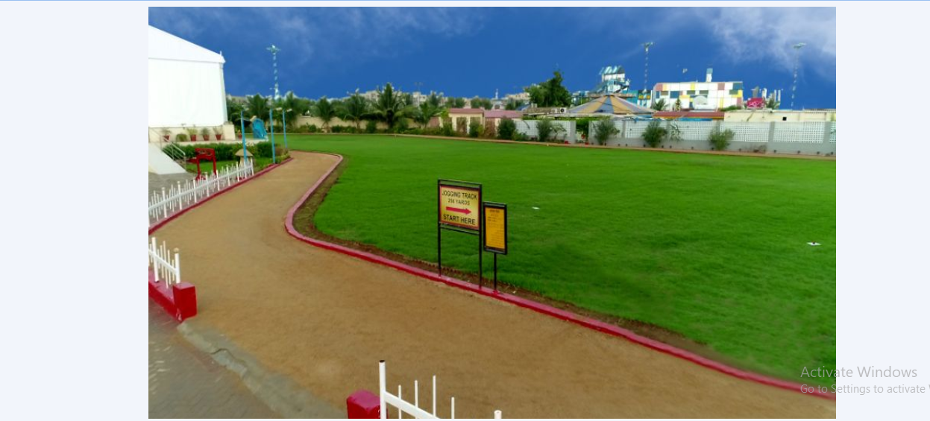

**Gym section**

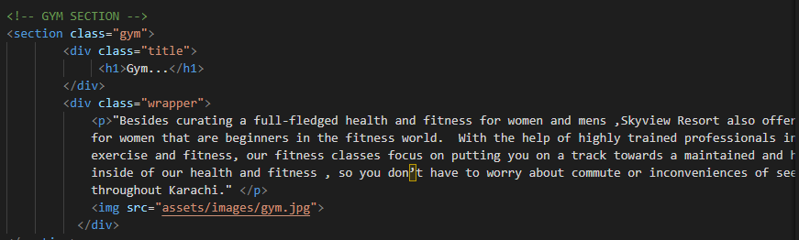

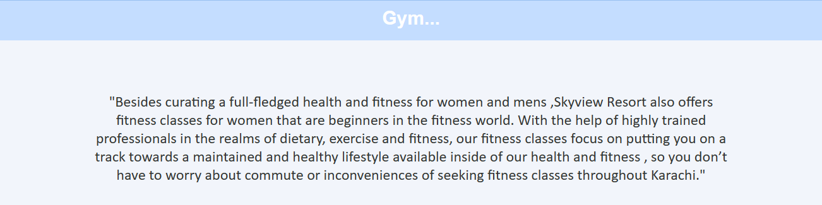

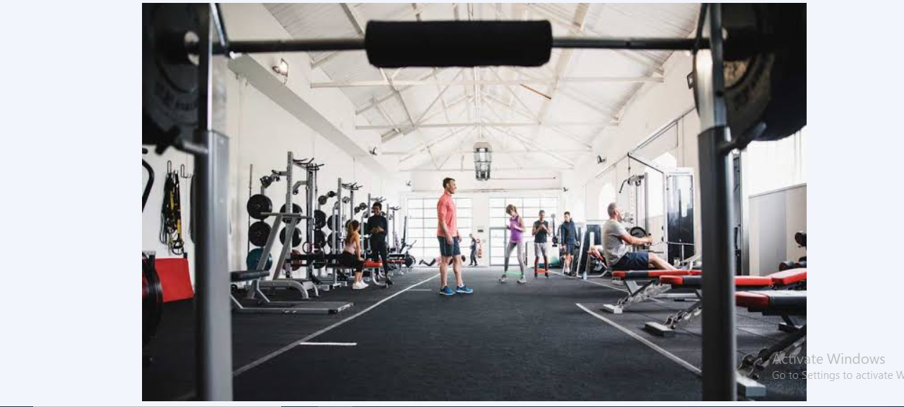

**Relaxation area**

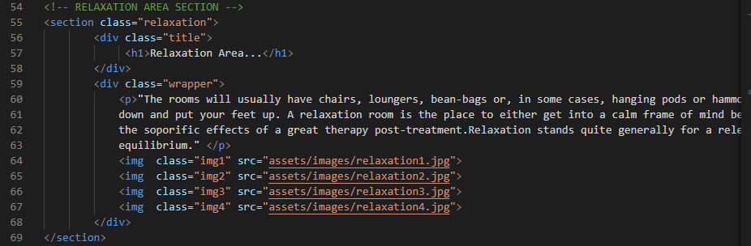

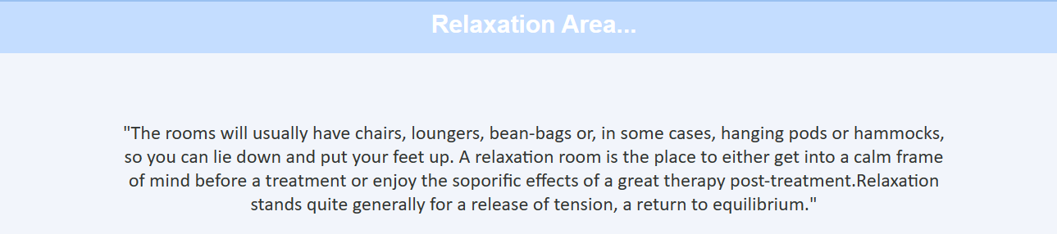

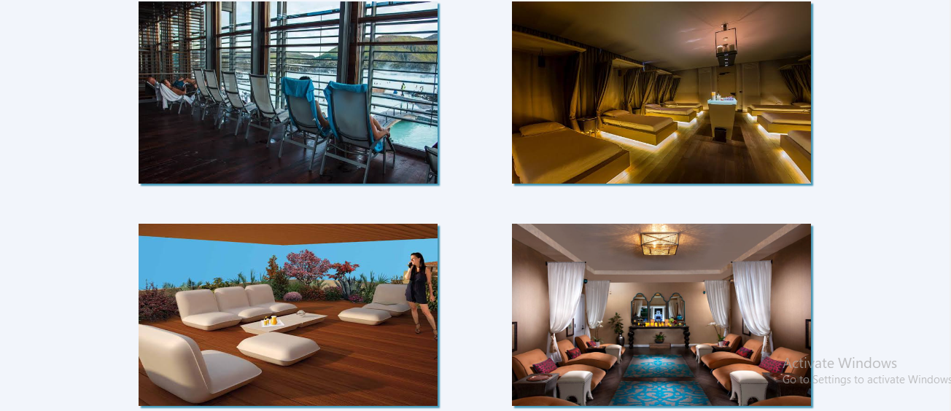

**MEMBERSHIP**

* This webpage is made for offering visitors our membership of the resort.
* In this page we have given full details about the membership and have also given an online form, so that if any visitor in interested in availing it can immediately fill the form and get through the process.

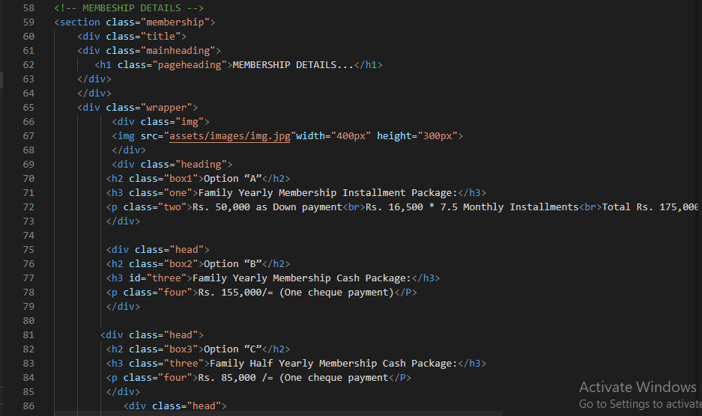

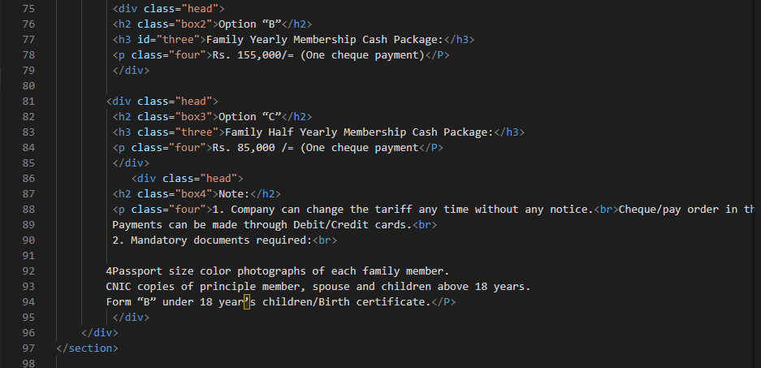

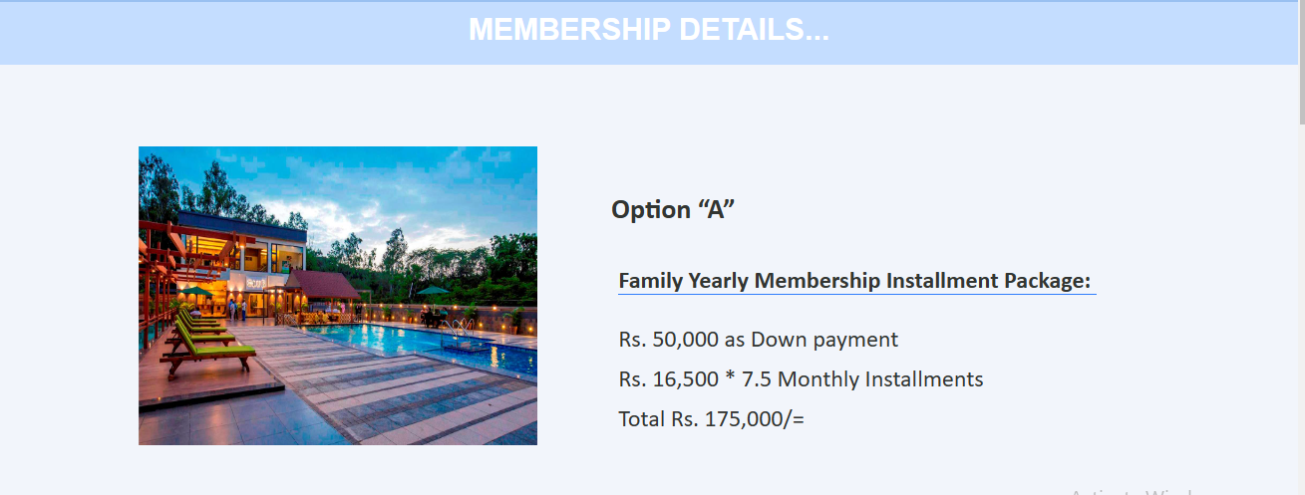

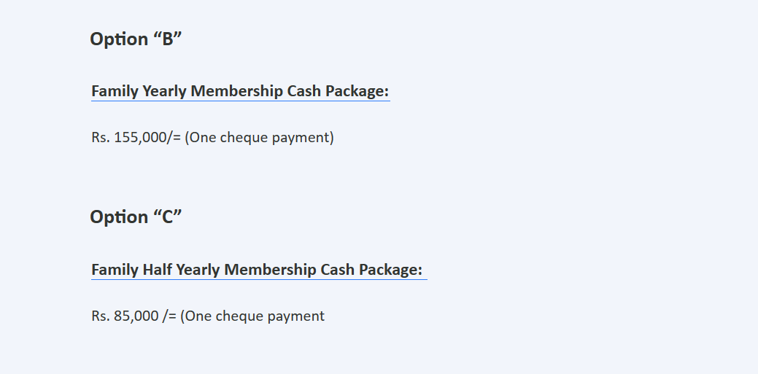

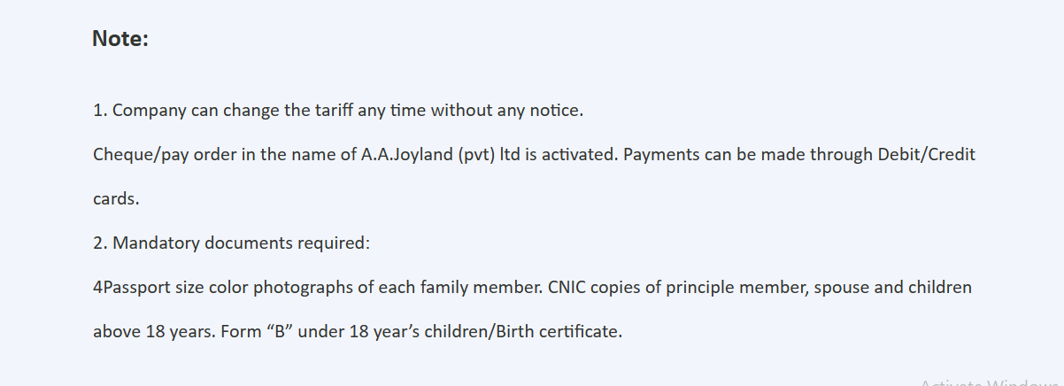

**Contact us**

* This webpage is developed so that the visitors of the website doesn’t face any difficulty in contacting the resort management.

